- Super cool and awesome
- Wins first place at competition
- Solves maze in .3 seconds

Buttons:
- One to stop the code
- One to start the code
- One to reset the code

Motor Driver:
- DRV8835
  - We want this embedded in the pcb

- Our Last Motor Driver:
  - Adafruit DRV8833 DC/Stepper Motor Driver Breakout Board

Motors:
- Micro Metal Gearmotor HPCB 6V with Extended Motor Shaft with encoder

MicroController:
- Raspberry Pi Pico v2 WH
- 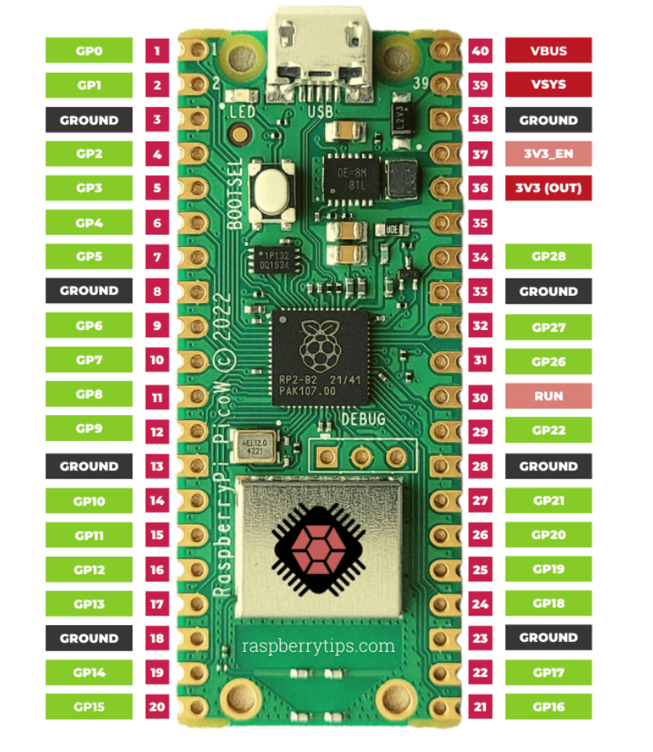

Power:
- Batteries (LiPo)
  - URGENEX 7.4V Lipo Battery
  - B6 Battery Charger
- Switching Regulator
  - Vmin input = 6, Vmax input = 9, Vout = 5, Iout = 0.5A
  - Pico (max out 300mA) ~150mA???, emitter 100mA, sensor 50mA, motor drivers minimal current, both motor encoders 25mA, buzzer minimal current
  - WEBENCH
  - TPS62163
  - 17V, 5Vout, 1A, Buck Converter with Power Good

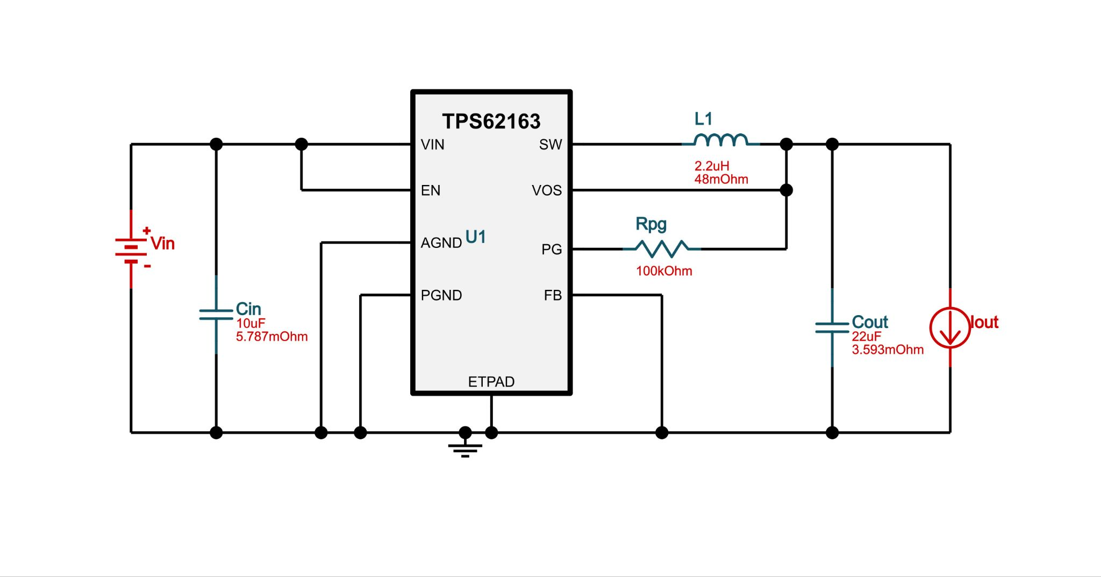

Our Last Pin output:
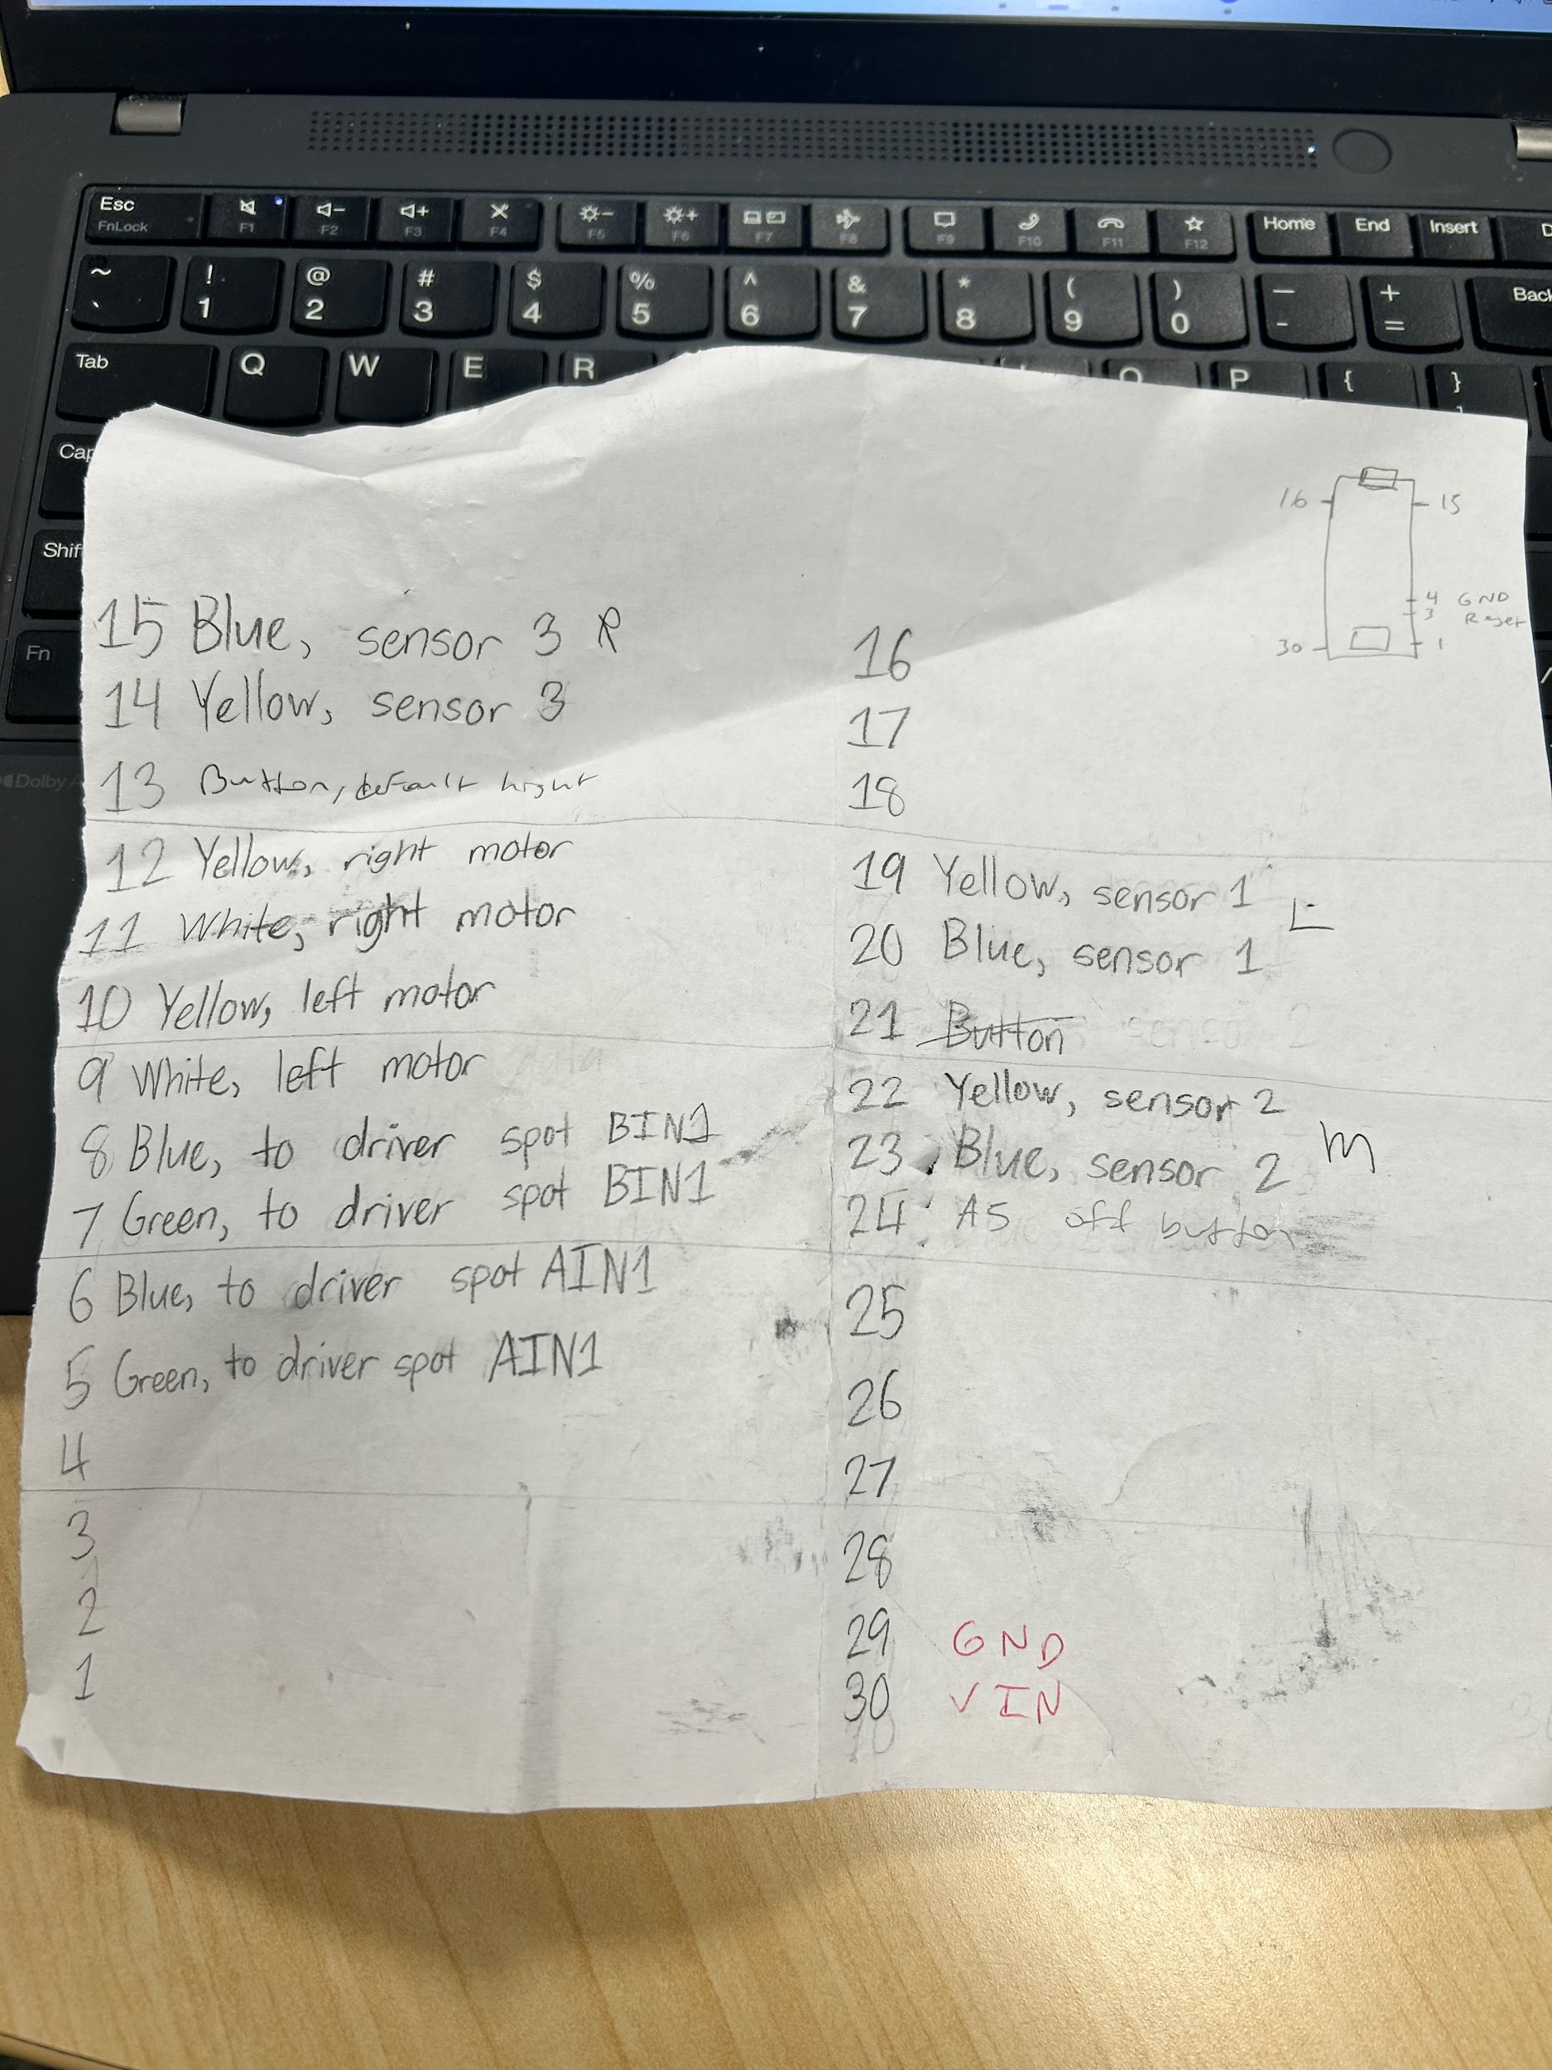

Sensors:
- TLCR5800 Visible RED LED’s
- BPW96B Phototransistors
Can also order IR sensors just so we have them.
- SFH 4545 Emitter
- TEFT4300 Receiver
- 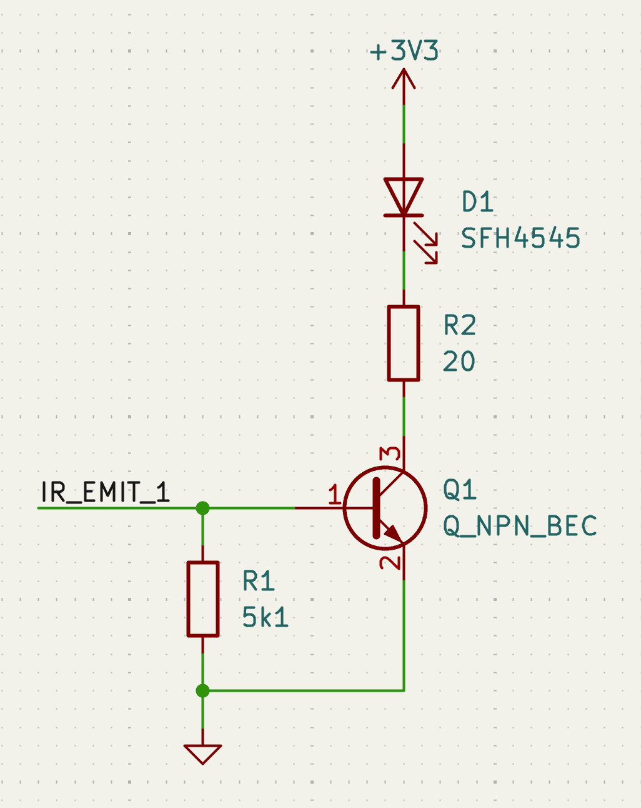
IMU:
- ?????????????????

Notes:

Use the full board and follow the spec sheet
Use some inductors on the motors for preventing stalling
Receiver into voltage divider

Need regulator for powering
300mA total

